FOSTER FAMILY / SPONSORSHIP PROGRAM MOBILE / WEB APPLICATION FOR ORPHAN OR POOR FAMILY CHILDREN SYSTEM
FINAL REPORT

CMSE 322

PROJECT NO : 15
GROUP NO : 1
PROJECT NAME : Foster Family / Sponsorship Program Mobile / Web Application for Orphan or Poor Family Children
PROJECT START DATE : March, 2023
PROJECT END DATE : May, 2023
SUPERVISOR : Assoc. Prof. Dr. Duygu Çelik Ertuğrul
SEMESTER TERM : Spring 2022/2023

Computer Engineering Department
Eastern Mediterranean University
Term: Spring 2022/2023

ABSTRACT

This final report deals with the design and development of a foster family/sponsorship program mobile and web application for orphan or poor family children.
This application is designed to provide a platform aimed at supporting orphan or poor family children. The application aims to bring together potential foster families or sponsors who support children in need and provide them with a healthy family environment.
The main features of the application include the ability to create a profile for foster families, view the profile of orphan or poor children, communicate and spend time together. Additionally, the app will offer options to donate so that foster families can make a financial contribution or help meet basic needs such as education and health.
This application will also be equipped with security and privacy measures, providing a secure communication environment for potential foster families and sponsors. Precautions such as authentication of users and background checks will be taken, thus aiming to protect the safety and welfare of orphaned or poor children.
As a result, the "Foster Family / Sponsorship Program Mobile / Web Application for Orphan or Poor Family Children" project includes a comprehensive mobile and web application that aims to use technology to support children in need and provide them with a better future. This application aims to bring together orphaned or poor children and potential foster families or sponsors to make a significant impact that can transform their lives.
Keywords: Foster family, Sponsorship program, Mobile application, Web application, Orphan children, Poor family children, Child support, Caregiver matching, Profile creation, Communication, Donation options, Security measures, Privacy protection, Identity verification, Background checks, Impact on children's lives, Technology for social impact, Future prospects, Transformational impact, Better future for children.

Table of Contents
ABSTRACT II
Table of Contents III
LIST OF FIGURES V
LIST OF TABLES VI
1. INTRODUCTION 1
2. PROJECT PLANNING AND MANAGEMENT 2
3. REQUIREMENTS ANALYSIS 3
3.1 Functional Requirements 3
3.2 Non-Functional Requirements 3
3.3 Realistic constraints 3
3.4 Ethical issues 3
4. DESIGN 4
4.1 High level design (architectural) 4
4.2 Software design 4
5. IMPLEMENTATION 5
5.1 Tools, technologies and platforms used 5
5.2 Algorithms 5
5.3 Standards 5
5.4 Detailed description of the implementation (coding) 5
6. TESTING 6
7. USER GUIDE OF THE SYSTEM 7
8. DISCUSSION 8
9. CONCLUSION 9
10. REFERENCES 10

LIST OF FIGURES

Figure 1 Gantt chart

Figure 2 Network Diagram 1

Figure 3 Network Diagram 2
Figure 4 High level design
Figure 5 Context diagram
Figure 6 use case diagram
Figure 7 sequence diagram
Figure 8 BPMN diagram
Figure 9 activity diagram
Figure 10 Home page 1
Figure 11 Home page 2
Figure 12 Home page 3
Figure 13 Donate page
Figure 14 Orphans and Poor families page 1
Figure 15 Orphans and Poor families page 2
Figure 16 Orphans and Poor families page 3
Figure 17 Orphans and Poor families page 4
Figure 18 Volunteers Page 1
Figure 19 Volunteers Page 2
Figure 20 Volunteers Page 3

LIST OF TABLES

Table 1 Resource Leveling Matrices
Table 2 Project Team Information
Table 3 Project Package Tables
Table 4 Milestones
Table 5 Procurement Table
Table 6 Project Economic Expectation
Table 7 Instrument / Equipment / Software / Release Purchases
Table 8 Quarterly Estimated Cost Form
Table 9 Analysis Table
Table 10 Description and Priority
Table 11 Stimulus/Response Sequences
Table 12 Description and Priority
Table 13 Stimulus/Response Sequences

1. INTRODUCTION

The aim of this project is to create a mobile and web application that leverages modern technology to support children in need and provide them with a better future. The application aims to bring together potential foster families or sponsors who support orphan or poor children and provide them with a healthy family environment.

The development of this app aims to make a significant impact in the lives of children and provide a way to transform their lives. An environment will be provided where caring families and sponsors can work together through this platform to sensitively respond to children's needs and provide them with love, safety and support.

This report will detail the project's development process, the app's key features, the technologies used to enhance users' experience, and the app's potential impact on children in need. Issues such as the app's security and privacy measures will also be covered, and future opportunities and expansion plans related to the project will be discussed.

In conclusion, the "Foster Family / Sponsorship Program Mobile / Web Application for Orphan or Poor Family Children" project is an important step to support children in need and offer them a better future by using technology. This practice aims to provide a loving family environment to orphans or poor children, while revealing the community's potential of helping and solidarity.

2. PROJECT PLANNING AND MANAGEMENT
Through out the whole project we followed the principles and life cycle indicated in our Project Planning and Management Report. There were no major changes in our implementation.
Resource Leveling (Resource Matrices):
Role  Activity | Project Manager | System Analyst | Programmer | Tester | Database Developer | User Interface Designer
Project Initiation Activities | x | x | x | x
Project Planning Activities | x | x | x | x
Project Design Activities | x | x | x | x | x
Project Code Development | x |  | x |  | x | x
Project Testing | x |  | x | x | x | x
Maintenance Activities | x | x | x | x | x | x
Project Closure | x | x
Table 1 Resource Leveling Matrices

2.1 Preliminary Project Information
Project No | 2
Project Name | Foster Family/Sponsorship Program Mobile/Web Application for Orphan or Poor Family Children
Start Date | March 2023
End Date | June 2023
Time | 3 Months
Team Information
Project Manager
Name Surname | Zeynep Pelin ÇOLAK | ID No | 17300009
Title/Role | Project Manager , System Analyst, Database Developer, Programmer, Tester, User Interface Designer
Address | Famagusta
Phone | 0533 872 12 02
Email | colakpelin8@gmail.com
Table 2 Project Team Information
2.2 Purpose and Target
Purposes:
- Supporting orphan or poor family children: The project is designed to support children in need and provide them with a healthy family environment. For this purpose, it aims to bring together potential foster families or sponsors with these children through mobile and web applications.
- Matching carers or sponsors with children in need: The app provides a matching mechanism that supports children in need and provides them with foster families or sponsors. In this way, it is ensured that children are placed in a safe family environment and supported.
- Providing secure communication, donation options and opportunities to meet basic needs: The app allows foster families and sponsors to securely communicate with children in need. It also provides users with donation options, enabling them to contribute financially to meet basic needs.

Goals:
- Developing a user-friendly mobile and web application: The project aims to design a user-friendly mobile and web application that users can easily use. In this way, it allows users to find and communicate with children who fit their resources and needs.
- Providing a secure and privacy-oriented platform: The application takes the necessary measures to protect the security and privacy of users. Measures such as authentication, secure data transmission, and privacy policies allow users to communicate and interact securely.
- Increasing the welfare of children in need: The project aims to increase the welfare of children in need. Children's health, education, shelter and other basic needs are met with the support and care provided by foster families or sponsors. In this way, children are provided with access to better conditions for a better future.
- Creating awareness and increasing social responsibility awareness in the society: The project aims to raise awareness for orphans or poor family children and to increase the social responsibility awareness of the society. Through the app, people have the opportunity to support children in need and realize that they have the potential to transform their lives.
- Assessing the scalability potential of the application: The project aims to make the application scalable in the future. The system that works successfully has the potential to reach wider audiences and offers the opportunity to extend a helping hand to more children in need.
- Conducting an impact assessment: The project aims to assess the impact of the implementation on children in need. Through statistical data, user feedback and field studies, it is aimed to determine the positive changes that the application has made in the lives of children and to measure the success of the project.

2.3 The Reason For Starting This Project
We started this project because we saw the potential to use technology to support orphan or poor family children and provide them with a better future. Many children around the world have been abandoned by their families or struggle to survive due to poverty. This situation prevents children from meeting their basic needs and growing up in a healthy family environment.
Traditional foster care or sponsorship programs play an important role in supporting children. However, it is seen that the opportunities offered by technology are not fully utilized. Recognizing this shortcoming, we decided to develop a mobile and web application to support the children of orphans or poor families.
This project demonstrates the potential to use technology for social responsibility. Through the app, potential foster families or sponsors can interact with children in need, support them and help them settle into a healthy family environment. In addition, thanks to the donations and financial contributions made through the application, the basic needs of children can be met and resources can be provided for their education.
The main aim of this project is to transform the lives of orphan or poor family children and offer them a better future. The app offers a secure communication and support mechanism that responds sensitively to the needs of these children. In addition, it aims to raise awareness in the society and increase the awareness of social responsibility.
2.4 Output/Success Criteria
- User Records:
- Users can sign up for a mobile or web application.
- Accurate and secure storage of user information.
- Family and Child Profile Management:
- Saving and updating Foster families profile information.
- Recording and updating profile information of forest or poor families.
- Saving and updating children's profile information.
- Twinning and Sponsorship Management:
- Matching Foster families and forest or poor families.
- Matching children with appropriate foster families or sponsors.
- Managing and updating matches.
- Communication and Interaction:
- Foster families and forest or poor families can communicate with each other.
- Ensuring communication between sponsors and children.
- Solving questions and problems through communication.
- Support and Resources:
- Providing support and resources to Foster families and to forest or poor families.
- Providing educational materials, guidance and counseling services.
- Ensuring access to resources for children's education, health and basic needs.
- Reporting and Monitoring:
- Monitoring and reporting of user activities.
- Reporting of matchmaking and sponsorship program progress.
- Evaluation of the effectiveness of the program and participant satisfaction.
- Security:
- Ensuring the confidentiality and security of user information.
- Implementation of data security and authorization controls.
- Complying with relevant legal regulations and data protection standards.
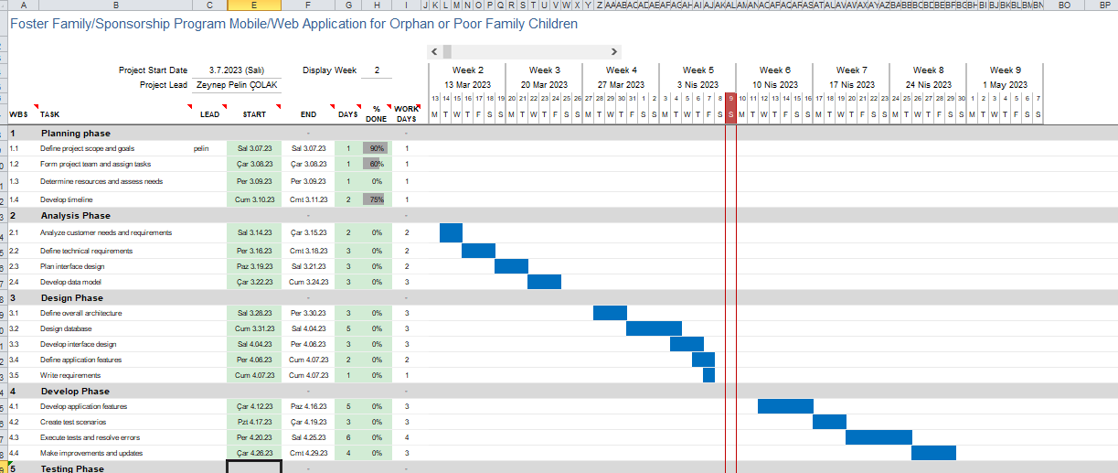
2.5 Gantt Chart
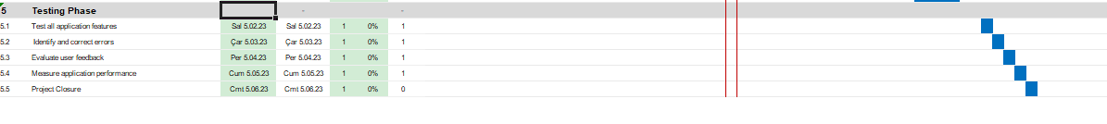
Figure 1 Gantt chart
2.6 Project Package Tables
Work Package No | 1
Work Package Name | Project Feasibility and Pre-Research (Feasibility Analysis)
Start-End Date and Time | 07.03.2023 – 11.03.2023
Related Organizations | -
1- List the activities of work packages.
1.1 Project Process and Economic Feasibility:
Project initiation: This phase includes defining the project objectives, stakeholders, and the overall scope of the project.
Planning: This phase involves developing a detailed project plan, which includes creating a work breakdown structure (WBS), scheduling, budgeting, and resource allocation.
Execution: This phase involves carrying out the project plan, monitoring progress, and making any necessary adjustments to keep the project on track.
Monitoring and control: This phase involves monitoring the project’s progress against the plan and making any necessary adjustments to keep the project on track.
Closure: This phase involves finalizing the project and ensuring that all objectives have been met.
Cost-benefit analysis: This involves identifying the costs associated with the project and comparing them to the potential benefits to determine if the project is economically feasible.
Return on investment (ROI): This involves calculating the expected return on investment for the project and comparing it to the cost of capital to determine if the project is financially viable.
Net present value (NPV): This involves calculating the present value of the future cash flows associated with the project and comparing it to the initial investment to determine if the project is economically feasible.
Payback period: This involves calculating the amount of time it will take for the project to generate enough cash flow to cover the initial investment.

2- Describe the methods and parameters that will be used for work package.
- Work breakdown structure (WBS): A WBS is a hierarchical decomposition of the project into smaller, more manageable components. Each component can be further decomposed into work packages, which can be assigned to individual team members or teams.
- Scope of work: The scope of work defines the deliverables, tasks, and activities that are required to complete a work package. This includes a detailed description of the work to be performed, the resources required, the schedule, and the budget.
- Responsibility matrix: A responsibility matrix defines the roles and responsibilities of each team member or team for each work package. This helps to ensure that everyone knows what is expected of them and who is responsible for each task.
- Timeline: A timeline provides a visual representation of the schedule for each work package, including start and end dates and any dependencies on other work packages.
- Performance measures: Performance measures are used to track progress and ensure that each work package is completed on time and within budget. This includes measures such as earned value, schedule variance, and cost variance.
- Quality standards: Quality standards define the criteria that must be met for each work package to be considered complete. This includes standards for deliverables, processes, and documentation.

- Risk management: Risk management involves identifying potential risks and developing strategies to mitigate them. This includes risks related to the completion of work packages, such as delays, cost overruns, or quality issues.
3- List the experiments, tests and analysis in the work package.
- Usability testing: Conducting user testing sessions to evaluate the ease of use, efficiency, and user satisfaction with the application.
- Security testing: Conducting penetration testing to evaluate the security of the application against potential threats.
- Performance testing: Testing the application under different loads and usage scenarios to ensure that it performs well and meets the required performance criteria.
- Functionality testing: Testing the application to ensure that it meets all functional requirements specified in the project scope.
- User acceptance testing: Conducting user acceptance testing to ensure that the application meets the needs and requirements of the target users.
- Compatibility testing: Testing the application to ensure that it is compatible with various devices, platforms, and browsers.
- Data analysis: Analyzing the user data collected by the application to gain insights into user behavior and preferences, and to improve the application's functionality and user experience.
- Localization testing: Testing the application to ensure that it is localized and translated correctly in different languages and cultures.
4- List the output of work package and its success criteria.
User Requirements Analysis Work Package
Output: Documented list of user requirements, needs, and preferences for the mobile/web application.
Success Criteria: The user requirements should be comprehensive, clear, and measurable, and must be approved by the project sponsor or stakeholders.
System Design Work Package
Output: Detailed system architecture and design documents that will be used for software development.
Success Criteria: The system design should be complete, coherent, and technically feasible. The design should meet the user requirements and address any potential issues or risks.
Software Development Work Package
Output: Fully-functional mobile/web application that meets the user requirements and system design specifications.
Success Criteria: The software should be completed on time, within budget, and meet the quality standards set by the project sponsor or stakeholders. The software should be tested for functionality and user experience.
Testing and Validation Work Package
Output: Test cases and validation reports for the mobile/web application.
Success Criteria: The application should be tested for functionality, usability, and security. All identified issues or bugs should be resolved, and the application should meet the quality standards set by the project sponsor or stakeholders.
Deployment Work Package
Output: Released and deployed mobile/web application.
Success Criteria: The application should be deployed on time, with minimal downtime or disruptions. The application should meet the quality standards set by the project sponsor or stakeholders.
Maintenance and Support Work Package
Output: Maintenance and support plan for the mobile/web application.
Success Criteria: The maintenance and support plan should be approved by the project sponsor or stakeholders. The plan should outline how the application will be updated, monitored, and maintained to ensure its continued functionality and usability. Technical support should be available to users.

5- Explain the relation of output with other work packages
The output of the "User Requirements Analysis" work package will provide input to the "System Design" work package, as it will define the needs and preferences of the users.
The output of the "System Design" work package will provide input to the "Software Development" work package, as it will specify the software requirements and architecture.
The output of the "Software Development" work package will provide input to the "Testing and Validation" work package, as it will be tested for functionality and user experience.
The output of the "Testing and Validation" work package will provide input to the "Deployment" work package, as it will ensure that the application meets the quality standards and is ready for release.
The output of the "Deployment" work package will provide input to the "Maintenance and Support" work package, as it will be responsible for fixing bugs, updating features, and providing technical support to the users.

1- List the activities of work packages.
1.1 Project Process and Economic Feasibility:
Project initiation: This phase includes defining the project objectives, stakeholders, and the overall scope of the project.
Planning: This phase involves developing a detailed project plan, which includes creating a work breakdown structure (WBS), scheduling, budgeting, and resource allocation.
Execution: This phase involves carrying out the project plan, monitoring progress, and making any necessary adjustments to keep the project on track.
Monitoring and control: This phase involves monitoring the project’s progress against the plan and making any necessary adjustments to keep the project on track.
Closure: This phase involves finalizing the project and ensuring that all objectives have been met.
Cost-benefit analysis: This involves identifying the costs associated with the project and comparing them to the potential benefits to determine if the project is economically feasible.
Return on investment (ROI): This involves calculating the expected return on investment for the project and comparing it to the cost of capital to determine if the project is financially viable.
Net present value (NPV): This involves calculating the present value of the future cash flows associated with the project and comparing it to the initial investment to determine if the project is economically feasible.
Payback period: This involves calculating the amount of time it will take for the project to generate enough cash flow to cover the initial investment.

2- Describe the methods and parameters that will be used for work package.
- Work breakdown structure (WBS): A WBS is a hierarchical decomposition of the project into smaller, more manageable components. Each component can be further decomposed into work packages, which can be assigned to individual team members or teams.
- Scope of work: The scope of work defines the deliverables, tasks, and activities that are required to complete a work package. This includes a detailed description of the work to be performed, the resources required, the schedule, and the budget.
- Responsibility matrix: A responsibility matrix defines the roles and responsibilities of each team member or team for each work package. This helps to ensure that everyone knows what is expected of them and who is responsible for each task.
- Timeline: A timeline provides a visual representation of the schedule for each work package, including start and end dates and any dependencies on other work packages.
- Performance measures: Performance measures are used to track progress and ensure that each work package is completed on time and within budget. This includes measures such as earned value, schedule variance, and cost variance.
- Quality standards: Quality standards define the criteria that must be met for each work package to be considered complete. This includes standards for deliverables, processes, and documentation.

- Risk management: Risk management involves identifying potential risks and developing strategies to mitigate them. This includes risks related to the completion of work packages, such as delays, cost overruns, or quality issues.
3- List the experiments, tests and analysis in the work package.
- Usability testing: Conducting user testing sessions to evaluate the ease of use, efficiency, and user satisfaction with the application.
- Security testing: Conducting penetration testing to evaluate the security of the application against potential threats.
- Performance testing: Testing the application under different loads and usage scenarios to ensure that it performs well and meets the required performance criteria.
- Functionality testing: Testing the application to ensure that it meets all functional requirements specified in the project scope.
- User acceptance testing: Conducting user acceptance testing to ensure that the application meets the needs and requirements of the target users.
- Compatibility testing: Testing the application to ensure that it is compatible with various devices, platforms, and browsers.
- Data analysis: Analyzing the user data collected by the application to gain insights into user behavior and preferences, and to improve the application's functionality and user experience.
- Localization testing: Testing the application to ensure that it is localized and translated correctly in different languages and cultures.
4- List the output of work package and its success criteria.
User Requirements Analysis Work Package
Output: Documented list of user requirements, needs, and preferences for the mobile/web application.
Success Criteria: The user requirements should be comprehensive, clear, and measurable, and must be approved by the project sponsor or stakeholders.
System Design Work Package
Output: Detailed system architecture and design documents that will be used for software development.
Success Criteria: The system design should be complete, coherent, and technically feasible. The design should meet the user requirements and address any potential issues or risks.
Software Development Work Package
Output: Fully-functional mobile/web application that meets the user requirements and system design specifications.
Success Criteria: The software should be completed on time, within budget, and meet the quality standards set by the project sponsor or stakeholders. The software should be tested for functionality and user experience.
Testing and Validation Work Package
Output: Test cases and validation reports for the mobile/web application.
Success Criteria: The application should be tested for functionality, usability, and security. All identified issues or bugs should be resolved, and the application should meet the quality standards set by the project sponsor or stakeholders.
Deployment Work Package
Output: Released and deployed mobile/web application.
Success Criteria: The application should be deployed on time, with minimal downtime or disruptions. The application should meet the quality standards set by the project sponsor or stakeholders.
Maintenance and Support Work Package
Output: Maintenance and support plan for the mobile/web application.
Success Criteria: The maintenance and support plan should be approved by the project sponsor or stakeholders. The plan should outline how the application will be updated, monitored, and maintained to ensure its continued functionality and usability. Technical support should be available to users.

5- Explain the relation of output with other work packages
The output of the "User Requirements Analysis" work package will provide input to the "System Design" work package, as it will define the needs and preferences of the users.
The output of the "System Design" work package will provide input to the "Software Development" work package, as it will specify the software requirements and architecture.
The output of the "Software Development" work package will provide input to the "Testing and Validation" work package, as it will be tested for functionality and user experience.
The output of the "Testing and Validation" work package will provide input to the "Deployment" work package, as it will ensure that the application meets the quality standards and is ready for release.
The output of the "Deployment" work package will provide input to the "Maintenance and Support" work package, as it will be responsible for fixing bugs, updating features, and providing technical support to the users.
1- List the activities of work packages.
User requirement analysis
System requirements specification
Feasibility analysis
System architecture design
Interface design
Database design
Module design
Algorithm design
GUI design
Security design
Prototype development
Testing and debugging
Performance optimization
Documentation
2- Describe the methods and parameters that will be used for work package.
User requirement analysis: Surveys, interviews, focus groups, and user personas.
System requirements specification: Functional and non-functional requirements, use cases, and requirement traceability matrix.
Feasibility analysis: Technical feasibility, economic feasibility, and operational feasibility.
System architecture design: High-level design, low-level design, and component diagram.
Interface design: Mockups, wireframes, and usability testing.
Database design: Entity-relationship diagram, normalization, and data dictionary.
Module design: Object-oriented design, class diagram, and dependency diagram.
Algorithm design: Pseudocode, flowchart, and complexity analysis.
GUI design: Visual design, layout design, and accessibility testing.
Security design: Threat modeling, risk assessment, and security controls selection.
Prototype development: Rapid prototyping and user testing.
Testing and debugging: Unit testing, integration testing, system testing, and debugging tools.
Performance optimization: Code profiling, benchmarking, and caching.
Documentation: User manual, technical manual, and release notes.
3- List the experiments, tests and analysis in the work package.
User acceptance testing: Verify if the system meets user requirements.
Usability testing: Evaluate the system's ease of use and user experience
Functionality testing: Verify the system's functional requirements
Performance testing: Measure the system's response time, throughput, and resource utilization
Security testing: Assess the system's vulnerability to attacks and data breaches
Code review: Evaluate the code's readability, maintainability, and scalability
System integration testing: Verify the system's compatibility with other systems and services
Stress testing: Evaluate the system's performance under extreme load conditions
Regression testing: Verify that new changes do not introduce defects in existing functionality.

4- List the output of work package and its success criteria.
User requirement analysis: User requirement specification document
System requirements specification: System requirement specification document
Feasibility analysis: Feasibility report
System architecture design: High-level design document, low-level design document, and component diagram
Interface design: Mockups, wireframes, and usability testing report
Database design: Entity-relationship diagram, database schema, and data dictionary
Module design: Class diagram, dependency diagram, and module interface specification
Algorithm design: Pseudocode, flowchart, and complexity analysis report
GUI design: Visual design, layout design, and accessibility testing report
Security design: Threat modeling report, risk assessment report, and security controls specification document
Prototype development: Functional prototype and user testing report
Testing and debugging: Test cases, test results, and bug report
Performance optimization: Performance benchmark report and optimization report
Documentation: User manual, technical manual, and release notes.

5- Explain the relation of output with other work packages
The output of each work package is an input to the next work package. For example, the user requirement specification document is an input to the system requirement specification work package. The system requirement specification document is an input to the system architecture design work package. The high-level design document and component diagram are inputs to the module design work package. The class diagram and module interface specification are inputs to the algorithm design work package. The functional prototype is an input to the testing and debugging work package.

Work Package No | 3
Work Package Name | Development of System Software (Development Stage)
Start-End Date and Time | 28.03.2023 – 08.04.2023
Related Organizations | -
1- List the activities of work packages.
Define software requirements
Design software architecture
Develop software modules and components
Integrate software components and modules
Test software functionality and performance
Fix defects and bugs
Deploy software to production environment
Provide post-deployment support

2- Describe the methods and parameters that will be used for work package.
For defining software requirements: interview stakeholders, gather user stories, analyze existing systems, and document requirements using tools such as use cases, user stories, and requirements documents.
For designing software architecture: use software design patterns, follow design principles such as SOLID, and use design tools such as UML diagrams.
For developing software modules and components: follow coding standards, use version control, and use appropriate programming languages and frameworks.
For integrating software components and modules: use integration testing, follow integration design patterns, and use integration frameworks.
For testing software functionality and performance: use automated testing, perform functional testing, load testing, and stress testing.
For fixing defects and bugs: use a bug tracking system, prioritize and triage bugs, and perform regression testing.
For deploying software to production environment: use deployment automation tools, follow deployment checklists, and monitor deployment progress.
For providing post-deployment support: provide helpdesk support, monitor system performance, and fix defects and bugs reported by users.
3- List the experiments, tests and analysis in the work package.
Unit testing
Integration testing
System testing
Acceptance testing
Performance testing
Load testing
Stress testing
Security testing
Usability testing
4- List the output of work package and its success criterias.
Software modules and components
Integrated software system
Tested and validated software system
Deployed software system to production environment
Bug-free and reliable software system
User-friendly and efficient software system
Meeting stakeholder requirements and expectations
Meeting project schedule and budget constraints

5- Explain the relation of output with other work packages
The output of this work package (developed and tested software system) is related to the output of the previous work packages (software requirements and software architecture) as it builds on the requirements and design to develop a working software system. The output is also related to the next work package (software maintenance and support) as it provides a reliable and maintainable software system for ongoing support and improvements.

Work Package No | 4
Work Package Name | Prototype Implementation and Test Study and Maintenance (Test & Maintenance stage)
Start-End Date and Time | 11.04.2023 – 06.05.2023
Related Organizations | -
1- List the activities of work packages.
Conducting system testing
Conducting user acceptance testing
Conducting performance testing
Conducting security testing
Conducting maintenance and support activities
Monitoring system performance and user feedback
Identifying and addressing defects or bugs
Updating system documentation and user manuals
2- Describe the methods and parameters that will be used for work package.
Developing test plans and test cases
Executing tests and recording results
Analyzing test results and identifying defects
Prioritizing and addressing defects
3- List the experiments, tests and analysis in the work package.
Conducting system testing to ensure all system components work together
Conducting user acceptance testing to ensure the software meets user needs
Conducting performance testing to ensure the software meets performance requirements
Conducting security testing to ensure the software is secure
4- List the output of work package and its success criterias.
Outputs:
Completed prototype implementation
Test plans and test result reports
Bug reports and solutions
Updated system documentation and user guides
Maintenance and support procedures
Success Criterias:
Availability of the prototype application at a certain level
Tests reach and pass a certain coverage area
Reducing the error rate below a certain level
Updated documentation to meet user needs
Maintenance and support procedures have a certain quality standard

5- Explain the relation of output with other work packages
Requirement Analysis: The outputs of the Prototype Application and Testing and Maintenance work packages help to verify the applicability and effectiveness of the requirements identified in the requirement analysis work package. Therefore, the prototype work and test results can assist in validating the outputs of the requirement analysis work package.
Design: The Prototype Application and Testing and Maintenance work packages test the accuracy of the design goals identified in the design work package. The prototype work and test results can confirm the accuracy of the design decisions made in the design work package or suggest the need for a re-evaluation of the design.
Coding: The Prototype Application and Testing and Maintenance work packages test the accuracy and functionality of the code written in the coding work package. Therefore, the prototype work and test results can help to detect and correct any errors made in the coding work package.
Testing and Verification: The Prototype Application and Testing and Maintenance work packages are directly related to the Testing and Verification work package. The prototype work and test results can help to verify the test scenarios identified in the Testing and Verification work package.
Maintenance: The Prototype Application and Testing and Maintenance work package is directly related to the Maintenance work package. The prototype work and test results can help to identify the maintenance requirements of the application and assist in planning the corrections to be made in the Maintenance work package
Table 3 Project Package Tables

2.7 Milestones
 | Description of Output | Expected Time Interval
1 | Planning Phase | 07.03.2023-12.03.2023
2 | Analysis Phase | 14.03.2023-24.03.2023
3 | Design Phase | 28.03.2023-07.04.2023
4 | Develop Phase | 12.04.2023-29.04.2023
5 | Testing Phase | 02.05.2023-06.05.2023
6 | Project Closure | 06.05.2023-06.05.2023
Table 4 Milestones

2.8 Procurement Tables
Risk | Probability | Effects | Your Strategy
Technical Risks: Any software development project is susceptible to technical risks, such as software bugs, data breaches, and system failures. These risks can lead to the loss of critical data or system downtime, which can significantly impact the program's effectiveness. | High | Tolerable | Technical Risk Management: To manage technical risks, the program can implement regular system updates, backups, and security checks to prevent and quickly address software bugs, data breaches, and system failures. The program can also consider using third-party vendors with experience in software development to provide additional support and expertise.
User Adoption Risks: The success of the Protective Family/Sponsorship Program mobile/web application relies on the adoption and engagement of its users, including sponsors and program administrators. If users do not adopt the application or fail to engage with the program, the impact of the program may be limited, and the resources invested in the project may not yield the desired results. | Moderate | Serious | User Adoption Risk Management: To manage user adoption risks, the program can invest in marketing and outreach efforts to promote the application and its benefits. The program can also provide incentives for users to engage with the program, such as recognition or rewards for sponsors who provide consistent support or for program administrators who meet performance targets.
Operational Risks: The operation of the Protective Family/Sponsorship Program mobile/web application may be susceptible to risks associated with human error, including program mismanagement, staff turnover, and inadequate training of program administrators. These risks can lead to delays in the sponsorship process, inefficient resource allocation, and a decrease in the program's effectiveness. | Low | Tolerable | Operational Risk Management: To manage operational risks, the program can develop detailed operating procedures and training materials for program administrators, including guidelines for program management, staff turnover, and training. The program can also consider using technology to automate processes where possible, reducing the risk of human error.
Legal and Compliance Risks: The development and operation of the Protective Family/Sponsorship Program mobile/web application may be subject to legal and compliance risks, including data privacy regulations, tax compliance requirements, and child protection laws. Non-compliance with these regulations can result in legal liability and reputational damage for the program and its stakeholders. | High | Serious | Legal and Compliance Risk Management: To manage legal and compliance risks, the program can establish policies and procedures to ensure compliance with relevant regulations, such as data privacy and child protection laws. The program can also engage legal counsel to provide guidance and support on regulatory compliance issues.
Financial Risks: The success of the Protective Family/Sponsorship Program mobile/web application may be dependent on adequate funding and the ability to sustain financial resources over time. If funding is insufficient or unstable, the program may be unable to meet the needs of the children it serves and may not be sustainable over the long term. | High | Tolerable | Financial Risk Management: To manage financial risks, the program can establish a detailed budget and financial plan to ensure that adequate resources are available to support the program's needs over time. The program can also explore alternate funding sources, such as grants or corporate sponsorships, to supplement existing funding streams.
Table 5 Procurement Table

2.9 Commercialization Potential
Audience and Market Analysis:
Confirmation of the existence of a need for forest or poor family children.
Identifying the targeted user segment (foster families, sponsors, promoters, etc.).
Evaluation of market size and growth potential.
Competition analysis:
Examination of other mobile/web apps available for similar purposes.
Identifying the strengths and weaknesses of the competition.
Exploring opportunities to create difference and competitive advantage.
Business Model Development:
Identifying sources of income (subscription, donations, advertising revenue, etc.).
Establishing the pricing strategy and determining the value proposition.
Seeking business partners and sponsorship opportunities.
Marketing and Promotion:
Developing an effective marketing strategy and making plans to reach the target audience.
Promoting the application through online and offline channels.
Creating interaction on digital platforms such as social media, blogs, news sites.
User Feedback and Improvement:
Establishment of mechanisms for collecting and analyzing user feedback.
Making continuous improvements on the usability, performance and user experience of the application.
Adding new features based on users' demands and expectations.
Expansion and Scaling:
Exploring possibilities to expand into new markets or regions after successful commercialization.
The application has a scalable infrastructure and is designed to meet increasing user demands.
Financial Goals:
Determination of fixed costs and creation of budget management processes.
Making income and expense estimations, evaluation of profitability potential.
Setting financial targets for the sustainability of the application.
Business Partnerships and Sponsorships:
Creating joint projects or sponsorships by collaborating with other organizations.
Generating additional income sources by making corporate sponsorships or advertising deals.
Data Analytics and Market Research:
Understanding market trends and customer behavior by collecting and analyzing user data.
Developing marketing strategies and recommendations for the target audience based on this data.
Investor and Financing:
Finding investors and financing sources who see the commercial potential of the application.
Making preparations and making presentations for the fundraising process.
Continuous Innovation and Update:
Keeping the application up-to-date by following technological developments and gaining competitive advantage by adding innovative features.
Continuously improve and innovate to adapt to user needs and market demands.
Brand Building and Credibility:
Creating a reliable brand image and making users trust the app.
Creating positive brand awareness by gaining the satisfaction and loyalty of users.
2.10 Project Economic Expectation
2- List your expectations to your team which are come by your project
Time-to-market (month): | June 2023
The expected increase in sales revenue (%): | 20%
The expected increase in market share (%): | 10%
Time to start to gain: | December 2023
Table 6 Project Economic Expectation

2.11 Instrument / Equipment / Software / Release Purchases

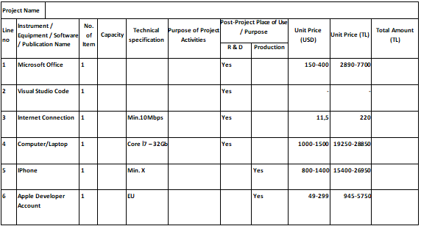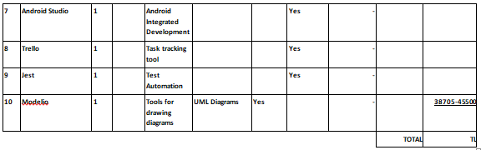

Table 7 Instrument / Equipment / Software / Release Purchases

2.12 Quarterly Estimated Cost Form
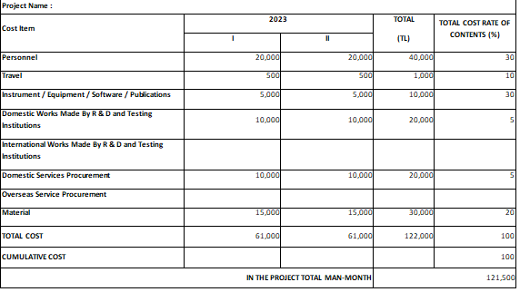 Table 8 Quarterly Estimated Cost Form

2.13 Pert Analyzing & Crashing Analyzing
Task ID | Task Name | Duration (days) | Dependency
A | Project Initialization/ Feasibility Studies | 4
B | Team Development/Scheduling | 4
C | Requirements Analysis and Development | 11 | A, B
D | Resources Procurement/Allocation | 5 | B, C
E | Development of System Model(s) | 5 | C, D
F | UI and Database Development | 7 | E
G | Coding and Implementation of Functionalities | 18 | E, F
H | Prototyping and Design Synthesis | 5 | D, E
I | Testing Activities and Modifications | 4 | H
J | Project Closure | 1 | H, I

Table 9 Analysis Table

Paths | Duration
A C D E F G H I J | 60
A C D E F H I J | 42
B C D E F G H I J | 60
B C D E F H I J | 42

Network Diagram (Critical Path)

A
5
4
E
D
C
11
5
F
B
7
4
J
I
H
1
18
4
51
G

Figure 2 Network Diagram 1
A
5
4
E
D
C
11
5
F
B
7
4
J
I
H
1
18
4
51
G

Figure 3 Network Diagram 2

3. REQUIREMENTS ANALYSIS

3.1 Functional Requirements
FREG 1- A registration form must be submitted for sponsors to register. The form should include information such as the sponsor's name, address, e-mail address, phone number, age and gender of the child they wish to sponsor.
FREG 2- A validation mechanism should be provided to verify the accuracy of the information entered in the registration form. The confirmation mechanism can be a confirmation email sent to the sponsor's email address or a telephone verification code.
FREG 3- Sponsors should be able to edit their personal information on their profile page. This will allow sponsors to change information such as addresses or phone numbers.
FREG 4- When sponsors want to sponsor a child, they can find children who meet their criteria by doing a search within the app. Search criteria can include age, gender, region, and family status.
FREG 5- When sponsors sponsor a child, they must be able to view their profile page. The profile page should contain information such as the child's name, living conditions, school information, health status.
FREG 6- Sponsors must have access to a payment page to manage their payments for their children. This page will provide an interface for sponsors to make their payments, allowing them to control the timing and amount of their payments.
FREG 7- Sponsors can make extra donations to improve children's living conditions. Donations can be made through the payment page.
FREG 8- Sponsors can receive regular reports to track children's health. These reports may include the health status of children and other relevant information.
FREG 9- Sponsors should have access to the support team within the app. This means sponsors can get help if they have any issues with the app.

Children and Families Features
Features for Kids:
Creating a profile: There will be a possibility to create a profile for each child. The profile will contain basic information such as the child's name, where they live, and their hobbies and interests.
Photo upload: Children will be allowed to upload photos to their profiles.
Sponsor search: Children will be able to search for people who want to sponsor them. Search results will be displayed along with sponsors' profiles.
Submitting a sponsorship request: Children will be able to send sponsorship requests to people who want to sponsor them.
Messaging: Children will be able to message with their sponsors.
Gift list: Children will be able to list gifts they would like to send to their sponsors. This list will make it easy for sponsors to send gifts based on children's wishes.
Features for Families:
Creating a profile: There will be a possibility to create a profile for each family. The profile will contain basic information such as family name, place of residence, number of family members.
Profile management of children: Families will be able to manage their children's profiles. This will mean kids update their information and upload their photos.
Search for sponsors: Families will be able to search for people who want to sponsor them. Search results will be displayed along with sponsors' profiles.
Sending a sponsorship request: Families will be able to send sponsorship requests to people who want to sponsor them.
Messaging: Families will be able to message their sponsors.
Gift list: Families will be able to list the gifts they want to send to their sponsors. This list will make it easy for sponsors to send gifts based on children's wishes.

3.2.1Description and Priority
Features | Explanation | Priority
Register | A registration form is presented for children and their families who want to register new to the application. | High
Profile Editing | Registered children and their families can update their profile information through the application. | Middle
Sponsor Search | Children and families can search for sponsors through the app to find a suitable sponsor. Search results are filtered according to the characteristics of the sponsors. | High
Sponsorship Application | Children and their families can apply for sponsorship through the app. The application waits for the sponsor to approve it. | High
Communicating | Sponsors can communicate with children and their families through the app. | Middle
Calendar | Sponsors and children/families can use the calendar via the app to keep track of meeting dates. | Middle
Giving Feedback | Children, families and sponsors can provide feedback on the application and the sponsorship process. | Low
Table 10 Description and Priority
3.2.2 Stimulus/Response Sequences
Feature ID | Feature Adı
CF1 | Profile creation for orphan/poor children
CF2 | Accept/reject sponsorship
CF3 | Sending a support message for orphan/poor children
CF4 | Track sponsors' payments
Table 11 Stimulus/Response Sequences
CF1: Profiling orphan/poor children:
Stimulus: User selects "Create profile as orphan/poor child".
Response: User can create a profile by entering information such as name, surname, age, gender, photo, school and accommodation.
CF2: Accept/reject sponsorship:
Stimulus: Sponsor selects "Accept/reject sponsorship".
Response: If the sponsor agrees to be the sponsor, the contract between the parties is created and the payment details are determined. If the sponsor refuses to sponsor, he may state the reason for the refusal.
CF3: Sending a support message for orphan/poor children:
Stimulus: User selects "Send support message".
Response: The user enters the message he wants to send to the orphan/poor child and sends it.
CF4: Tracking sponsors' payments:
Stimulus: Sponsor selects "Payment tracking".
Response: Sponsor can view payment dates, payment amounts and payment status (paid/unpaid) on the payment tracking page.

Functional Requirements
FREG 1-Listing of Children
The user of the system should view the list of orphan or poor family children through the application.
Listed children should include information such as name, age, gender, place of residence, school status.
Each listed child must be selectable to access their detailed information.
FREG 2-Foster/Sponsor Matching
The user of the system should be able to match the children with the foster family/sponsor via the application.
For the matching process, users should be allowed to set search criteria.
After the pairing process takes place, a notification should be sent by the system.
FREG 3-Updating Child Information
The information of orphan or poor family children should be able to be updated through the system.
The information update should include all information about the children, such as name, age, gender, residence, school status.
FREG 4-Planning Social Events
The user of the system should be able to plan social activities for children through the application.
For the planning process, the date, time, place, event type and other details should be determined.
Scheduled events must be viewable on the children's profile.

FREG 5-Children's Safety
Children's safety should be ensured through the application.
Children's foster families or sponsors should be able to control the needs of children by periodically updating the application.
A feature should be provided within the system to report and manage suspicious activities.

Admin Features
Admin Login: Enter the administrator account, user name and password to log in to the system.
Admin Dashboard: Admin has a panel where he can view and edit data about the application.
User Management: The administrator can view the list of registered users, create, edit or delete user accounts.
Sponsor Management: The administrator can view the list of registered sponsors, create, edit or delete sponsor accounts.
Orphan/Poor Family Management: The administrator can view the list of registered orphan/poor families, edit or delete family information.
Content Management: Admin can manage, update or delete content shared in the app.
Statistics and Reporting: The administrator can view statistics and reports about the sponsorship program in the application.
System Management: The administrator can manage system settings, perform maintenance, and perform system updates to ensure the performance and security of the application.
User Support: The administrator can answer users' questions about the application and provide technical support.
Session Management: The administrator can manage the sessions of logged in users and remind users to log out when needed.

Description and Priority
Feature | Description | Priority
Login | Administrators can login to the application. | High
Managing Users | Being able to perform operations related to users. | High
Authorization | Determine what actions users can take in the application. | Middle
Reporting | Obtaining reports about users, sponsors and children. | Middle
System Configuration | Managing application settings. | Low
Table 12 Description and Priority

Stimulus/Response Sequences
Stimulus | Response
When a new foster family account is created | The system verifies the account information and creates the account.
When a foster family account is updated | The system verifies the updated information and updates the account.
When a foster family account is deleted | The system deletes the account and removes all related data.
When a new donation is made | The system verifies the donation information and records the donation.
When donation information is updated | The system verifies the updated information and updates the donation information.
When a donation is deleted | The system deletes the donation and removes all related data.
When a new orphan/low income family account is created | The system verifies the account information and creates the account.
When an orphan/low income family account is updated | The system verifies the updated information and updates the account.
When an orphan/low income family account is deleted | The system deletes the account and removes all related data.
Table 13 Stimulus/Response Sequences

Functional Requirements
Authentication: The administrator must be able to login to the system with his user name and password. Username and password must be stored securely using encryption techniques.
User Management: The administrator should be able to manage the authorization levels and other information of the users in the system. This can be done by adding, deleting or editing users.
Data Management: The administrator should be able to manage the data used in the application. This can be done by adding, deleting or editing data.
Reporting: The administrator should be able to generate reports on application data. These reports provide information about system performance, user behavior, etc. should contain information about.
System Configuration: The administrator should be able to manage the settings of the application. These settings include application behavior, interface settings, etc. should include features such as

Security Management: The administrator should be able to manage the security of the application. This process includes updating the technologies used for the security of the application, limiting access to users' accounts, etc. contain transactions.
Backup and Recovery: The administrator should create procedures for backing up and recovering data in the system. These procedures can be used to ensure that data is restored in the event of an application crash or data loss.

3.2 Non-Functional Requirements

Performance Requirements
The performance requirements are specified for the application to run quickly and efficiently. The mobile app and web app should always be available, and users' waiting times should be as short as possible. Processing times, page load times, and data processing speed should be minimized, and client-server communication should be performed with minimum latency. The application's memory usage and data storage capacity should also be optimized and run at the highest possible performance level.

Safety Requirements
The application should take the necessary measures to protect the private information of children and families. This information should only be used for the purposes of the program and under no circumstances should it be shared with third parties.
The app should perform background checks as necessary to ensure the safety of sponsoring families, children and families, and a proper match between registered users should be made.
The app should provide filtering and blocking measures to prevent children and families from being exposed to potentially dangerous or harmful content.
The application should provide appropriate instructions and recommendations to ensure the safety of users during the use of the program.

Security Requirements
Authentication and Authorization: All users must pass through the authentication and authorization process. The features that users can access should be determined by their roles.

Data Security: Users' data must be safe and measures must be taken to prevent access by malicious attackers. To protect data privacy, user data must be encrypted and database security must be ensured.

Update and Maintenance: It is necessary to make regular updates and maintenance in the system. This helps minimize security vulnerabilities.

DoS Protection: The servers of the application must be protected against DoS attacks. In the event of such an attack, the application may become unusable.

Preventing Unauthorized Access: Appropriate controls and blocking must be made to prevent unauthorized access to the system. This can prevent malicious attackers from damaging the app.

Security Tests: The application should be checked regularly with security tests and security vulnerabilities should be detected and fixed. This can keep user data safe.

Software Quality Attributes
Usability: The application shall have a user-friendly interface and be intuitive to use. The text and icons used shall be easily understandable by the target audience of the application.

Maintainability: The application shall be designed with modular and scalable code, making it easy to maintain and upgrade.

Reliability: The application shall be available 24/7 with a minimum downtime of 99%. It shall be able to recover from any unexpected failures or errors within a reasonable amount of time.

Scalability: The application shall be designed to handle a large number of users and be able to scale up or down based on the load.

Portability: The application shall be able to run on various platforms such as Android, iOS, and web browsers.

Performance: The application shall respond quickly to user input, and the response time shall be within acceptable limits. The application shall be able to handle multiple requests at the same time without any performance degradation.

Testability: The application shall be designed with testability in mind, with automated testing tools and techniques used throughout the development process to ensure quality and minimize defects.

Accessibility: The application shall be accessible to users with disabilities, including visual and hearing impairments. The application shall comply with accessibility standards such as WCAG 2.0 AA.

Interoperability: The application shall be able to interact with other systems and software, allowing data to be exchanged securely and efficiently.

Internationalization and Localization: The application shall be designed to support multiple languages, time zones, and cultural differences to allow for a global audience.

Business Rules
Child information registered in the system can only be updated by authorized personnel.
A sponsor's donation must be credited directly to the account of the child they wish to donate to.
The system should ensure that sponsors' payments are processed securely and transparently.
The system should allow monitoring of sponsorship activities so that it can keep track of and report on sponsors' support for a child.
The system should allow sponsors to update their profile information and terminate sponsorship.
The system should not prevent sponsors from re-sponsoring a child they previously sponsored.
The system must ensure that any payments made to foster families are properly documented.
The system should receive regular feedback on the care services provided by foster families to children.
The system must ensure that foster families have adequate resources to meet the health, education and other needs of children.
The system must ensure that all information given to foster families remains confidential.

Other Requirements
Legal Requirements
The application must comply with all relevant local, state, and federal laws and regulations, including but not limited to those related to child protection and privacy.

Security Requirements
The application must have appropriate security measures to protect user data and prevent unauthorized access or modification. This includes secure storage of user data, encryption of sensitive data, and user authentication and authorization mechanisms.

Performance Requirements
The application must be designed to perform efficiently and respond quickly to user requests. Response times must be fast enough to avoid user frustration and abandonment of the application.

Compatibility Requirements
The application must be compatible with a wide range of devices and operating systems to ensure maximum accessibility and usability. It should also be designed to work well with different screen sizes, resolutions, and orientations.

Reliability Requirements
The application must be reliable and available to users whenever they need it. It must be able to handle high traffic loads and prevent crashes or downtime. The application must also be designed to recover quickly from any failures or errors.

Maintenance Requirements
The application must be designed to be easily maintained and updated. This includes providing a simple and intuitive interface for managing content and user accounts, as well as easy-to-use tools for troubleshooting and bug fixing.

3.3 Realistic constraints
- Budget Constraints:
Budget constraints set for the project.
Development, infrastructure, marketing and maintenance costs stay within budget.
- Time Constraints:
The requirement that the project be completed within the specified time.
The development, testing, distribution and marketing processes are in line with the timeline.
- Technological Limitations:
The technologies to be used require a certain compatibility or integration.
Technological constraints to adapt to existing infrastructure and resources.
- Data Security and Privacy Restrictions:
Taking necessary security measures to protect user data.
Complying with data privacy laws and protecting users' personal information.
- Local Regulations and Legal Restrictions:
Compliance with relevant local regulations and legal requirements.
Legal restrictions, particularly on the protection of children, family relations and financial transactions.
- User Demands and Expectations:
Limitations based on users' suggestions, requests and feedback.
Identifying requirements to meet user experience and usability expectations.
- Infrastructure and Resources:
Infrastructure constraints based on requirements such as business, server infrastructure, internet connection.
Limitations of human resources, technical capabilities and other resources.
- Availability and Accessibility Restrictions:
Usability and accessibility requirements across different platforms (mobile, web).
Considering factors such as different devices, screen sizes and access barriers.

3.4 Ethical issues

Child Rights and Protection:

Implementation of policies and guidelines to protect children's rights.

Taking care of children's privacy and safety.

Establishing fast and effective response mechanisms in case of any abuse, abuse or neglect.

Data Privacy and Security:

Taking appropriate measures to ensure the confidentiality and security of user data.

To prevent unauthorized use of personal information and to protect against data breaches.

Fair and Equal Treatment:

Ensuring fair and equitable treatment between Foster families, forest or poor families and children.

To prevent discrimination to ensure that everyone has access to equal opportunities.

Transparency of Sponsorship and Donations:

Ensuring transparency about the sources, use and distribution of sponsorship or donations.

Financial accountability to inform donors and gain their trust.

Cultural Sensitivity:

Adopting a respectful approach to children and families from different cultures.

Adapting the program to take into account cultural diversity and special needs.

Application Usage and Accessibility:

The app is available and accessible to everyone.

Providing features and access methods suitable for the needs of users with disabilities.

Partnerships and Connections:

Collaboration with business partners, sponsors or sponsors in accordance with ethical standards.

Compliance with ethical values and prevention of conflicts of interest.
4. DESIGN

4.1 High level design (architectural)
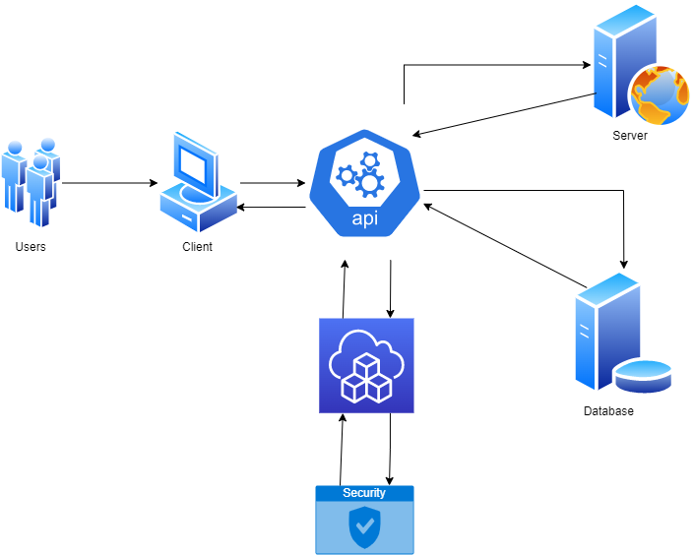
Figure 4 High level design
The explanation of the main components are presented here :
Client Layer:
This layer will allow users to access the application. React Native technology will be used for mobile devices, Node.js and Express technologies will be used for web applications.
Server Layer:
This layer will manage the business logic and database operations of the application. The server layer will be designed using Node.js and Express technologies.

Database Layer:
This layer will manage the database operations of the application. It will be designed using MongoDB database.
API Layer:
This layer will manage the data communication between the client layer and the server layer. The API layer will be designed using RESTful APIs.
Cloud Services:
The app will be designed using cloud services like Firebase. These services will make the application more secure and scalable and speed up the development process.
Security Layer:
This layer will ensure the security of the application. Data communication will be secured using the HTTPS protocol.
The data flow between these components will be as follows: Users will access the application through the client layer. The client layer will send requests to the API layer and perform data operations through the API layer, server layer and database layer. The data will be sent to the client layer via the API layer. Cloud services will be used for the security and scalability of the application.

4.2 Software design

In this section we will explain our system using UML Tools and diagrams to give our development team and the end customers who understand and have a knowledge about software engineering terminology a deeper presentation.

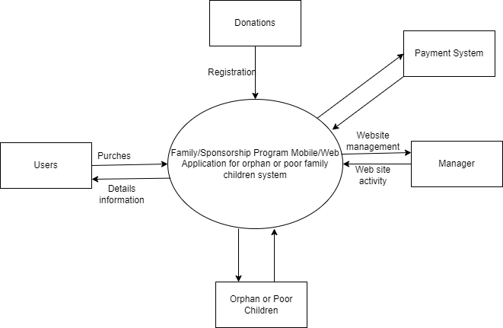
Figure 5 Context diagram

Users: Users of the application. These users can register, request sponsorship, donate and communicate with children using the app.

Donation Payment System: This component allows users to make donations and make payments. Users can make donations and complete payment transactions using this system.

Administrator: This component, which is the administrator or authority of the application, performs the overall management and operational functions of the system. The administrator manages user accounts, oversees donations and monitors children's needs.

Secondary/Primary/Kindergarten Orphans and Poor Children: This component represents orphans and poor children enrolled in the program in secondary, primary or kindergarten. Users can contact these children, request sponsorships, and assist them.

Receiving a Donation Request: When users want to donate, they can submit their donation requests to the system.

Making a Payment Transaction: The Donation Payment System receives the donation amount and payment method of the users and performs the payment transaction securely.

Sending Payment Confirmation: The system will send a confirmation message to users when the payment process is complete and notify that their donation has been received successfully.

USE CASE DIAGRAM
User Registration: A new user can register on the application by providing personal information such as name, contact information, and address.
Search for Children: A registered user can search for orphan or poor children based on various criteria such as age, gender, and location.
Sponsorship Request: A user can apply to sponsor a child by selecting a child from the search results and submitting the sponsorship request.
Approval of Sponsorship Request: An administrator can approve or reject a user's sponsorship request after verifying the user's credentials and ensuring that the child is eligible for sponsorship.
Payment Processing: A user can make a payment for the sponsorship fee through the application using a credit card or other payment methods.
Communication with Foster Family: A user can communicate with the foster family of the sponsored child through the application, exchange messages, and receive updates on the child's progress.
Tracking Child's Progress: A user can track the progress of the sponsored child by receiving periodic updates on the child's education, health, and overall well-being.
End Sponsorship: A user can end the sponsorship of a child by sending a request through the application. The application will notify the foster family and administrator of the end of the sponsorship.
Reports: Administrators can generate various reports such as a list of sponsored children, sponsors' details, and payment details, etc.

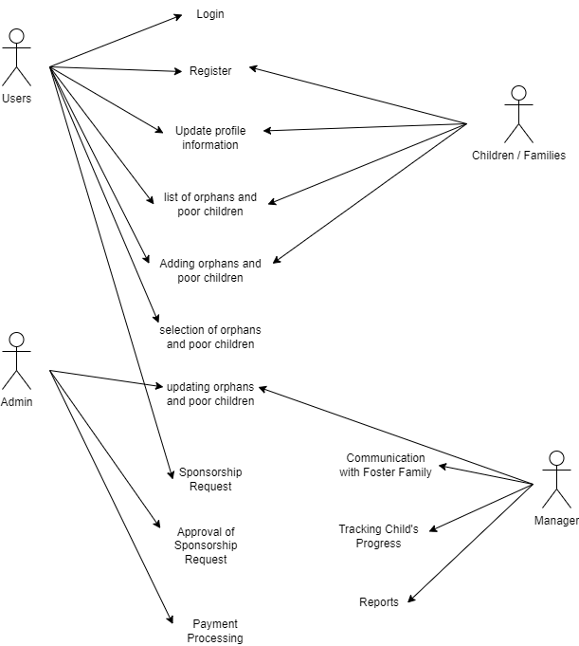
Figure 6 use case diagram
SEQUENCE DIAGRAMS
This sequence diagram shows the flow of interactions between the user, application, database, administrator, payment gateway, and foster family during the process of a user applying to sponsor a child. It begins with the user registering and logging into the application, searching for a child to sponsor, and submitting a sponsorship request. The application then processes the request, notifies the administrator, and updates the database with the request status. The administrator can then approve or reject the request, and the application updates the database accordingly. The user makes a payment through the payment gateway, and the application updates the database with payment information. The foster family is notified about the new sponsorship and can accept it. The application provides the user with the foster family's contact information so that they can communicate.
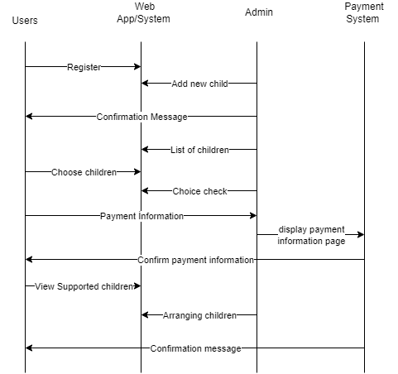
Figure 7 sequence diagram

BUSİNESS PROCESS MODELİNG (BPMN)
Children or families download the app and start the registration process.
The application provides a registration form and collects necessary information (eg name, age, gender, educational background, income level, contact information, etc.).
After completing the registration form, the application verifies the information and completes the registration.
Pairing Process:
After registration is complete, the app analyzes the needs and expectations of children or families.
The app searches profiles of sponsored families and makes suitable matches.
After matching is done, the app brings together sponsored families and protected children.
Sponsorship Relationship:
Sponsored families and protected children communicate through the app and initiate sponsorship relationships.
Sponsored families provide financial and/or emotional support to protected children.
The application manages the communication of sponsored families and protected children and ensures that the process goes smoothly.
Progress Monitoring:
The app monitors and regularly reports the progress of sponsored families and protected children.
The app identifies the needs of sponsored families and protected children and provides the necessary support.
The progress monitoring process ensures that sponsored families and protected children stay connected and engaged on an ongoing basis.
Termination:The relationship of sponsored families and protected children may terminate after a certain period of time or when the children achieve independence.
The application terminates the relationship of sponsored families and protected children and supports both parties.
The app collects feedback from sponsored families and protected children and makes improvements in the process.
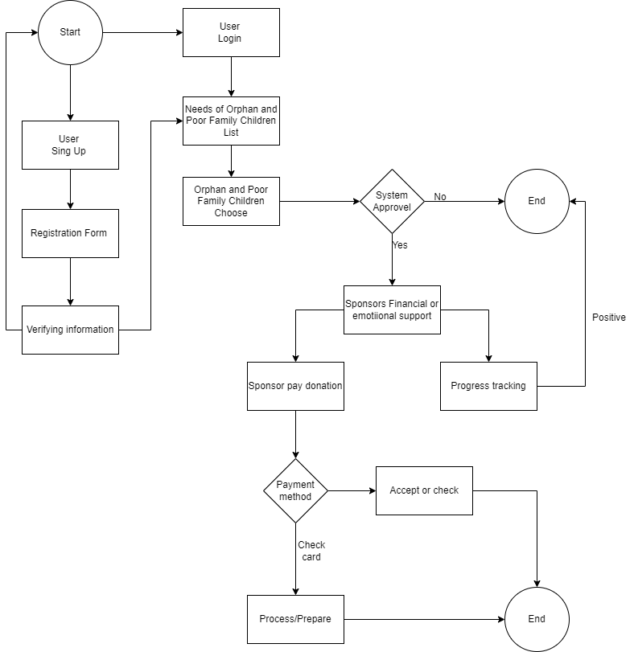
Figure 8 BPMN diagram

ACTIVITY DIAGRAM
This activity diagram shows the steps of the user opening the app, logging in, selecting a child, being redirected to the child's profile page, and starting the child's sponsorship. It is also stated that when the user makes a sponsorship application, the system administrator is informed and the sponsorship will only start if it is approved.
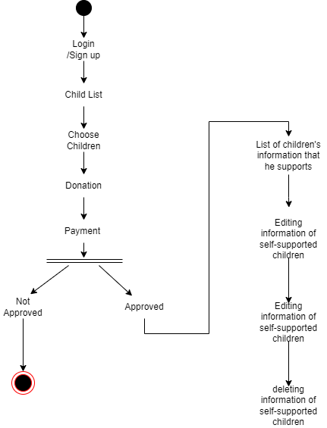
Figure 9 activity diagram

ER DIAGRAM
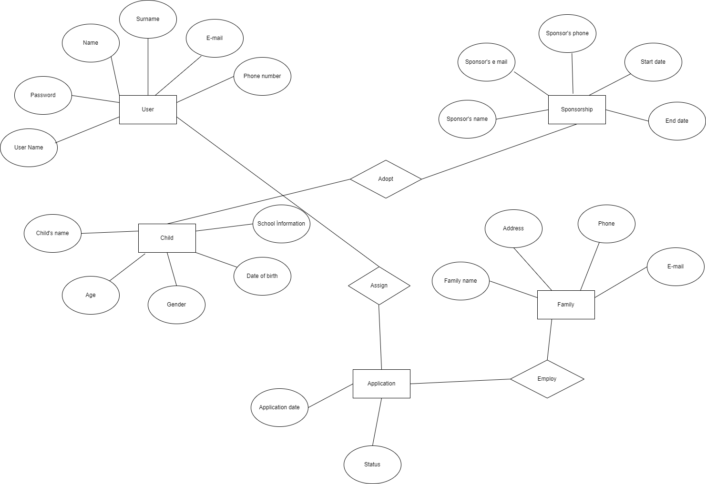
Entities:
Child: This entity represents each child in the system. Features include information such as the child's name, ages, contact information, address, health status, and school status.

Family: This entity represents poor families who need help. Features may include data such as the family's name, contact information, address, and information of other family members.

Donor: This entity represents individuals or organizations willing to donate. Features may include data such as the donor's name, contact information, and donation amount.

Relationships:
Child-Family: This relationship indicates that each child is related to a family. Every child belongs to a poor family and is considered a member of the family. This relationship is used to indicate the family to which the children belong.

Child-Donor: This relationship indicates that each child is dependent on one or more donors. Donors can donate to meet the needs of a particular child. This relationship is used to track children's donations and to keep track of which child donors are helping.

Family-Donor: This relationship indicates that each family is dependent on one or more donors. Donors can donate to meet the needs of a particular family. This relationship is used by families to track donations and to keep track of which family donors are helping.

Data Base Table
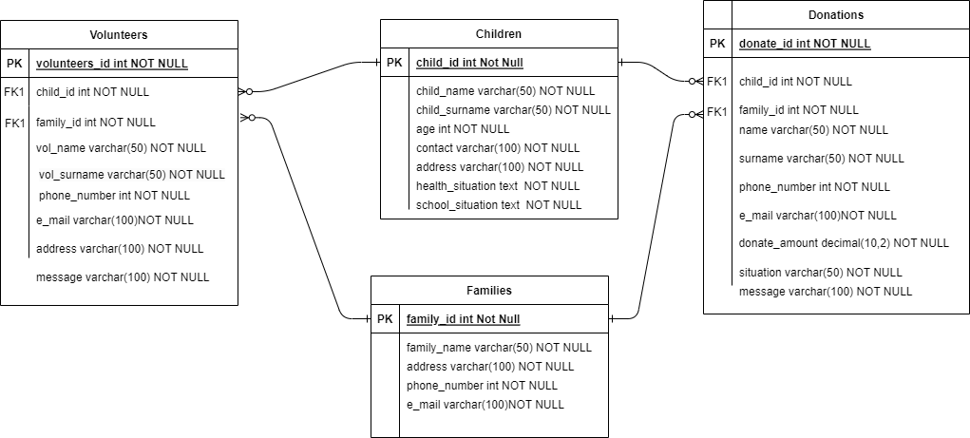
CREATE TABLE Children ( child_id INT PRIMARY KEY, child_name VARCHAR (50),child_surname varchar(50), age int NOT NULL,contact varchar(100),address varchar(100),health_situation text ,school_situation text,);
CREATE TABLE Families( family_id INT PRIMARY KEY,family_name VARCHAR (50),address varchar(100),phone_number int,e_mail varchar(100),);
CREATE TABLE Volunteers( volunteers_id INT PRIMARY KEY, child_id int Foreign Key, family_id int Foreign key, vol_name varchar(50),vol_surname varchar(50),phone_number int,e_mail varchar(100),address varchar(100),message varchar(100),);
CREATE TABLE Donations (donate_id int PRIMARY KEY , child_id int Foreign Key, family_id int Foreign key, name varchar(50), surname varchar(50),phone_number int,e_mail varchar(100), donate_amount decimal(10,2), situation varchar(50),message varchar(100),);

5. IMPLEMENTATION

5.1 Tools, technologies and platforms used

Various tools, technologies and platforms are used when creating a website. The basic programming language is PHP and its core functions are developed using this language. MySQL database is used to store data. The design of the website is created with HTML and CSS, and the themes are shaped using these languages. JavaScript is used for user interactions and special features. Tools like Bootstrap, which are popular CSS frameworks, can be used for rapid development and responsive design.

5.3 Standards

For Requirements Analysis: IEEE Standard was adhered to.

For Web Development: We used W3C (World Wide Web Consortium), the international standard for the World Wide Web (W3).

For Security: Advanced Encryption Standard was taken into consideration.

5.4 Detailed description of the implementation (coding)
<?php
/**
* The Template for displaying all single posts.
*
* @package Betheme
* @author Muffin group
* @link https://muffingroup.com
*/

get_header();
?>

<div id="Content">
<div class="content_wrapper clearfix">

<div class="sections_group">
<?php

$is_toolset = get_post_meta( get_the_ID(), '_views_template', true );

if ( $is_toolset || 'builder' == get_post_meta( get_the_ID(), 'mfn-post-template', true ) ) {

// template: builder

$single_post_nav = array(
'hide-sticky' => false,
'in-same-term' => false,
);

$opts_single_post_nav = mfn_opts_get('prev-next-nav');
if (isset($opts_single_post_nav['hide-sticky'])) {
$single_post_nav['hide-sticky'] = true;
}

// single post navigation | sticky

if (! $single_post_nav['hide-sticky']) {
if (isset($opts_single_post_nav['in-same-term'])) {
$single_post_nav['in-same-term'] = true;
}

$post_prev = get_adjacent_post($single_post_nav['in-same-term'], '', true);
$post_next = get_adjacent_post($single_post_nav['in-same-term'], '', false);

echo mfn_post_navigation_sticky($post_prev, 'prev', 'icon-left-open-big');
echo mfn_post_navigation_sticky($post_next, 'next', 'icon-right-open-big');
}

while (have_posts()) {

the_post();

$mfn_builder = new Mfn_Builder_Front(get_the_ID());
$mfn_builder->show();

}

} else {

// template: default

while (have_posts()) {
the_post();
get_template_part('includes/content', 'single');
}
}

?>
</div>

<?php get_sidebar(); ?>

</div>
</div>

<?php get_footer();

6.TESTING
Modules of the application were tested manually for any bugs, crashes as well as any unexpected output results. Expected outputs were compared with the outputs perceived during the testing and subsequent changes and modification to the code were made in case of mismatch. The validity of the end product has been verified by installing the software on several android devices with different specifications in order to assess visuals, resolution, colors and compatibility of the application. This method also allowed the use of these android devices to test the app during its development, not only to validate the end product. Testing results showed an overall good standing of the end product with major features of the application working smoothly without crashes or unexpected outputs.
Test -Case ID: | TC -01
Test –Case Name: | Donate Form
Pass/Fail Criteria: | System show display donate page and update database with the changes made by the user
Input Data: | Donate, First name, Last name, Phone number, E-mail, Donation amount, message
Test Proceduce | Test Results
Step 1:Click Donate | System shows “Donate” panel
Step 2:Edit Form | System saves database with new form

Test -Case ID: | TC -02
Test –Case Name: | Foster Family Request Form
Pass/Fail Criteria: | System show display child details page and update database with the changes made by the user
Input Data: | Child name,Parent First name, Parent Last name, Phone number, E-mail, Address, message
Test Proceduce | Test Results
Step 1:Click details | System shows “Enter Details” panel
Step 2:Edit Form | System saves database with new form

7. USER GUIDE OF THE SYSTEM

Home Page
The logo is located on the left side of the upper part of our homepage. Next to it is a navigation menu for easy access to site content. As it begins to descend into the middle, there is a slogan, a photo and a donation button. Below it is money collected so far, became a foster family ,helped the family and helped the child. The following page contains a short introductory text, slogan, images and visuals.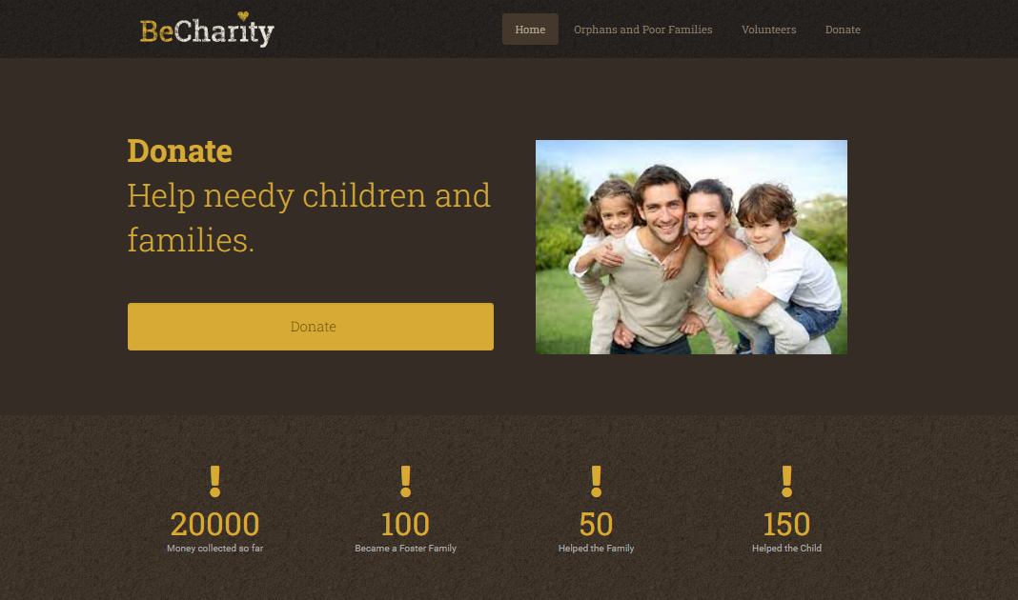
Figure 10 Home page 1

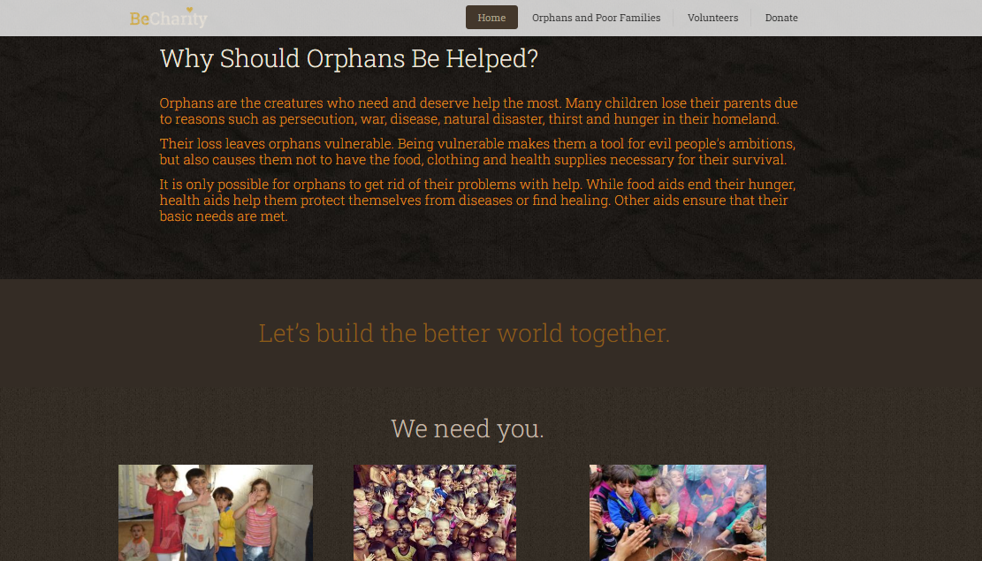
Figure 11 Home page 2

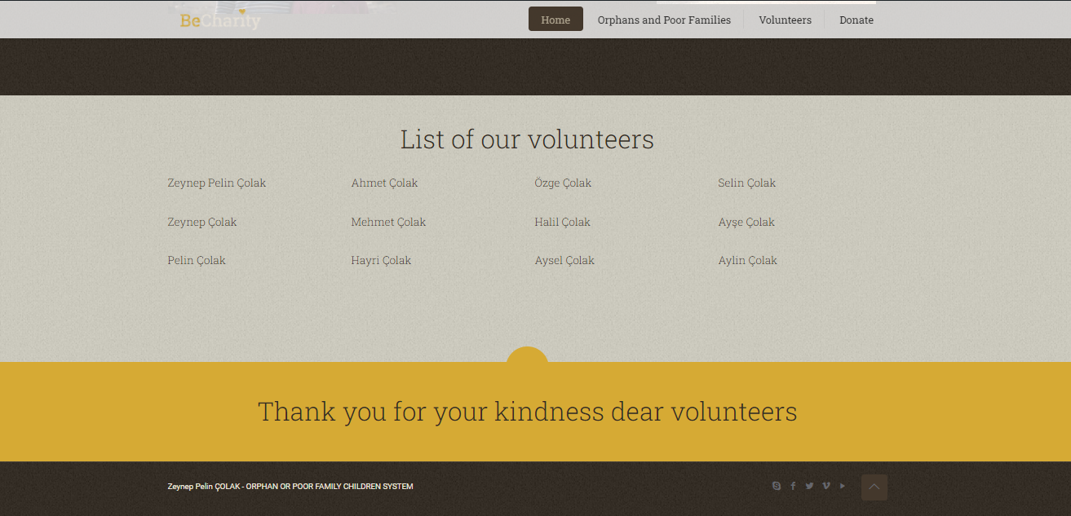
Figure 12 Home page 3

Donate Page
When we return to the top of our page and click on the donation button to donate, it sends us to the donation page. There is a donation form on the donation page. The content of the form: you can write what you are donating for, name, surname, phone number, e-mail, the amount of donation you want to make, if you want, the message and if your name is not added to the page, he completes his donation anonymously.

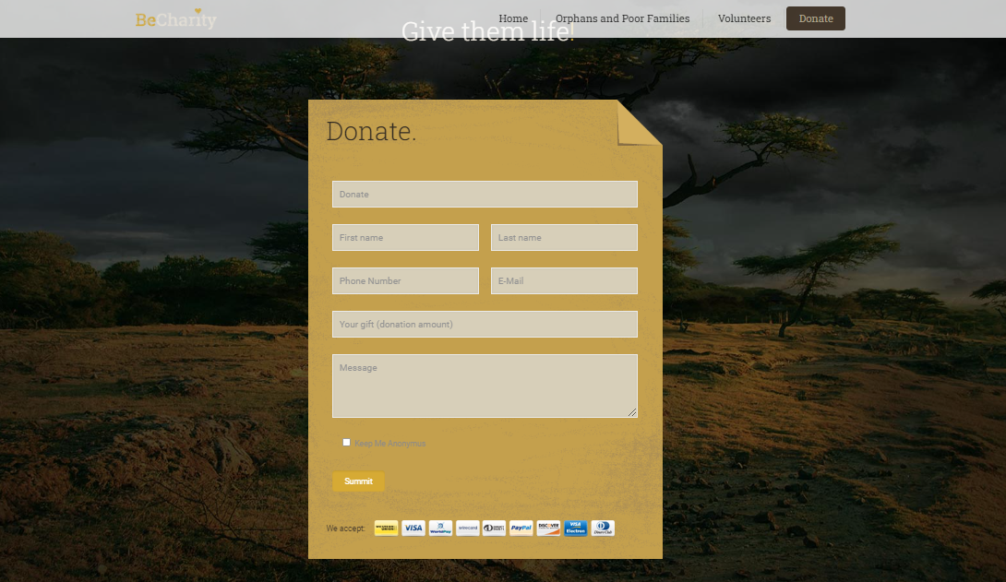
Figure 13 Donate page

Orphans and Poor families page
Children and families in need are listed on the page. There is a detail button to see the images and details of children or families. The rest of the page continues in this way. There is a thank you message on every page.
Clicking the button to see the details of any child or family sends it to the page with the child's or family's information. On this page, there is detailed information and general information about the child or a list of needs.
There are two forms at the bottom of the page. There is either a form where the child or family can donate according to their needs, or there is a request to become a foster family for the child. After filling in their information, they can appear anonymously if they wish.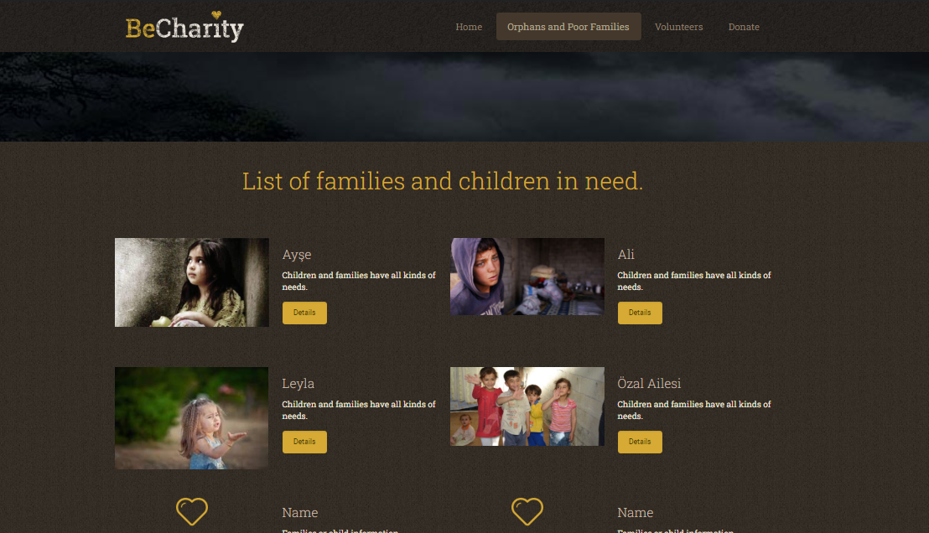
Figure 14 Orphans and Poor families page 1

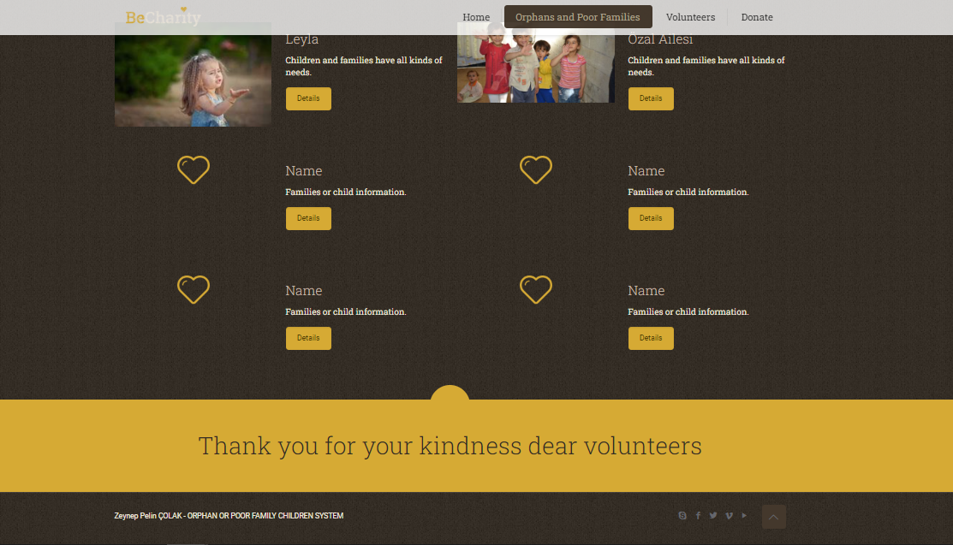
Figure 15 Orphans and Poor families page 2

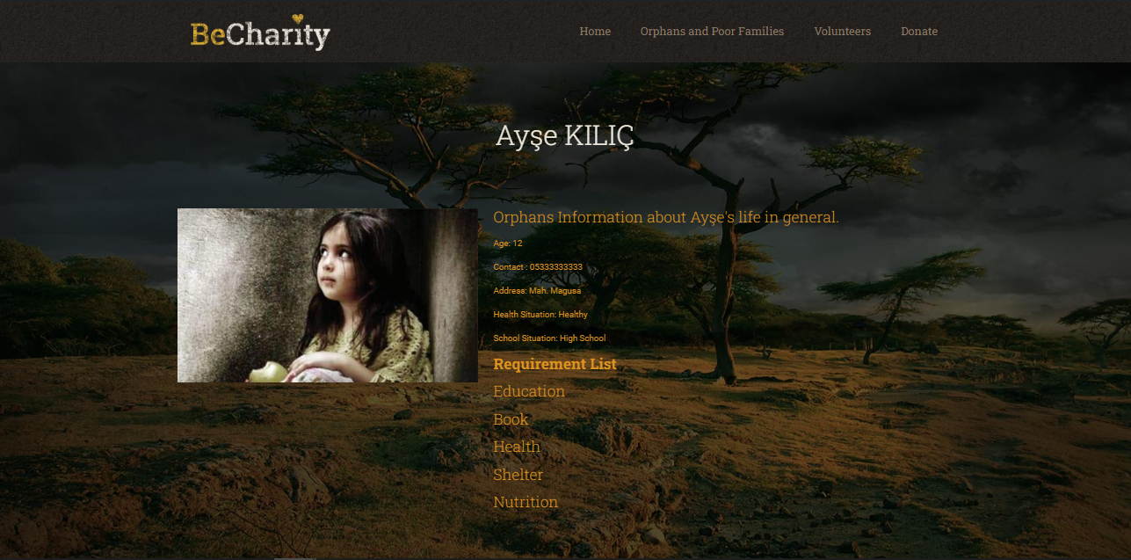
Figure 16 Orphans and Poor families page 3

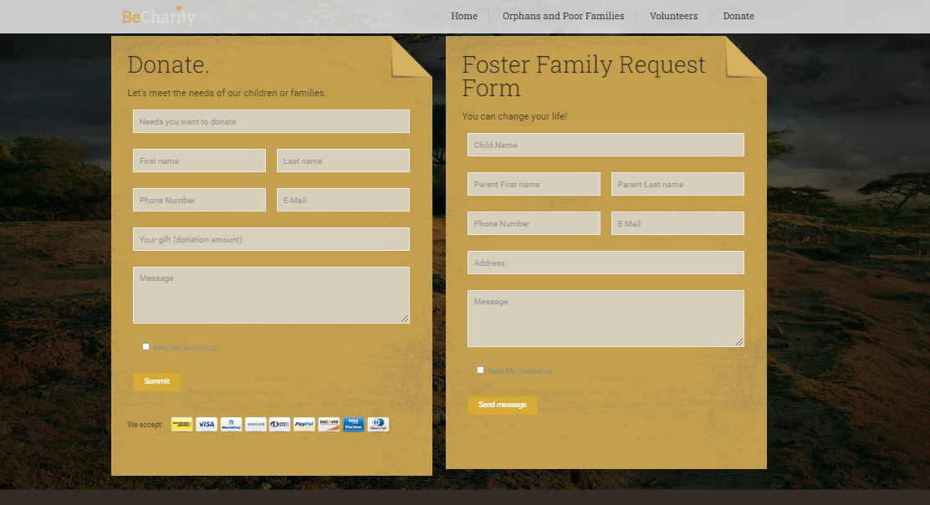
Figure 17 Orphans and Poor families page 4
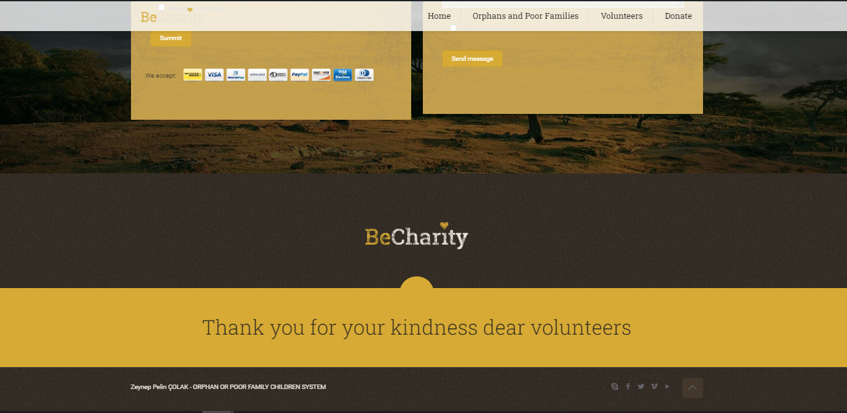

Volunteers Page
On this page, there is a join button if they want to volunteer. And there are lists of volunteers at the bottom of the page. When they click on the join button, they are sent to the volunteer page, where they can fill in their information and apply.The rest of the page shows the help so far.

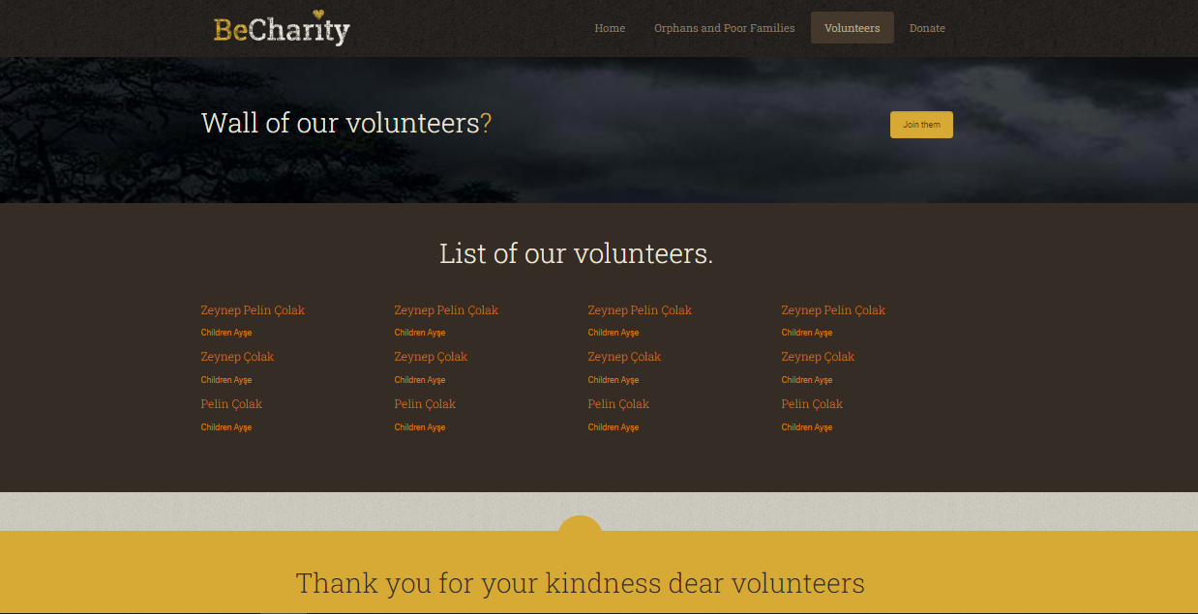
Figure 18 Volunteers Page 1
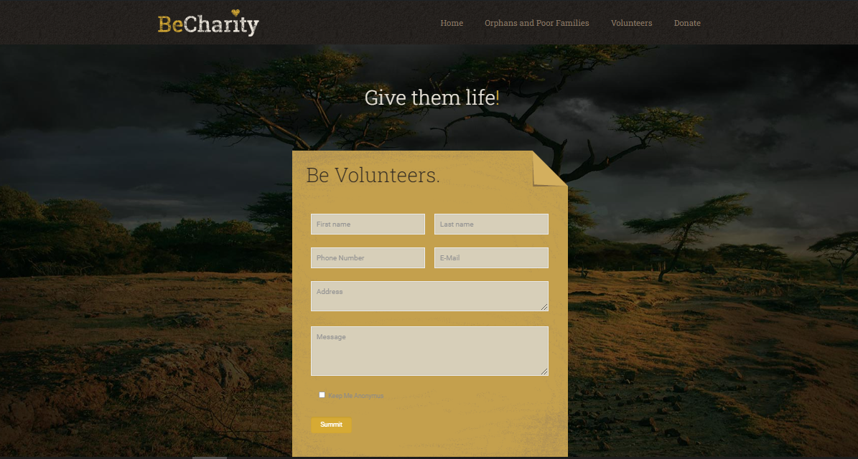
Figure 19 Volunteers Page 2

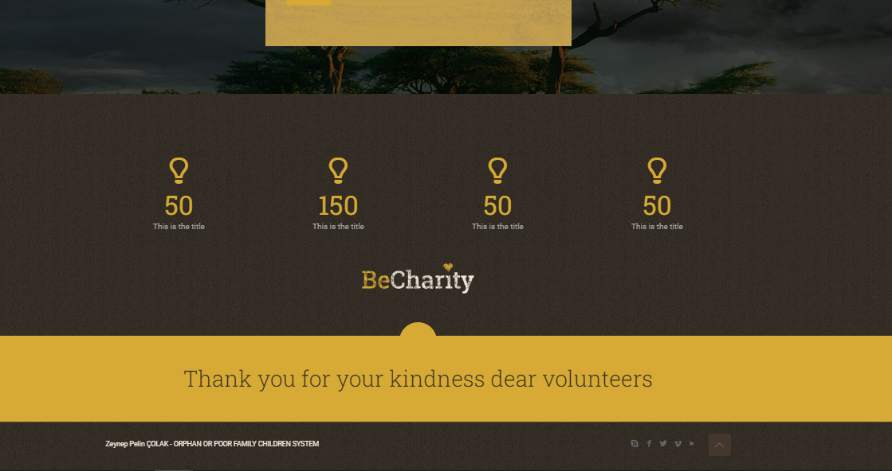
Figure 20 Volunteers Page 3

8. DISCUSSION

The FOSTER FAMILY/SPONSORSHIP PROGRAM MOBILE/WEB APPLICATION FOR ORPHAN OR POOR FAMILY CHILDREN SYSTEM aims to have a positive impact on a global, economic, environmental, and societal level. By facilitating the connection between foster families or sponsors and orphan or poor family children, the solution addresses several key aspects that can bring about significant benefits for individuals, communities, and society as a whole.

Economically, the solution can provide financial support and resources to orphan or poor family children who are in need. By connecting them with foster families or sponsors, it opens up opportunities for financial assistance, educational support, and healthcare provisions. This support can have a long-term positive impact on the economic well-being of these children, potentially breaking the cycle of poverty and providing them with a better chance for a prosperous future. Additionally, the solution can also benefit foster families or sponsors by allowing them to contribute to society in a meaningful way, providing them with a sense of fulfillment and personal growth.

From an environmental perspective, the solution can indirectly contribute to sustainability efforts. By helping orphan or poor family children access educational resources, it promotes knowledge sharing and can empower them to become future advocates for environmental conservation. Furthermore, by utilizing mobile and web applications, the solution reduces the need for paper-based processes, minimizing paper usage and contributing to the reduction of deforestation.

Societally, the solution has the potential to make a significant positive impact. By connecting orphan or poor family children with foster families or sponsors, it provides them with stable and nurturing environments, reducing the likelihood of involvement in crime or negative social circumstances. The solution also aims to improve access to educational resources and medical assistance, which can lead to better overall health and well-being for these children. Moreover, by promoting inclusivity and support for vulnerable members of society, the solution fosters a sense of community and empathy, strengthening social cohesion.

Overall, the FOSTER FAMILY/SPONSORSHIP PROGRAM MOBILE/WEB APPLICATION FOR ORPHAN OR POOR FAMILY CHILDREN SYSTEM has the potential to make a transformative impact on a global scale. By addressing economic disparities, promoting environmental consciousness, and fostering societal well-being, it creates opportunities for a brighter future for orphan or poor family children while bringing individuals, communities, and society closer together.
9. CONCLUSION

The FOSTER FAMILY/SPONSORSHIP PROGRAM MOBILE/WEB APPLICATION FOR ORPHAN OR POOR FAMILY CHILDREN SYSTEM is a comprehensive solution designed to address the needs of orphan or poor family children by connecting them with foster families or sponsors. Throughout the development and implementation of this system, our team has worked diligently to create a platform that brings positive change to the lives of these vulnerable children while considering the broader impact on the global, economic, environmental, and societal context.

The impact of our solution is far-reaching. Economically, it provides financial support and resources to orphan or poor family children, offering them opportunities for education, healthcare, and overall better prospects for their future. By connecting them with foster families or sponsors, we empower both the children and the families, fostering economic growth and breaking the cycle of poverty.

In terms of the environment, our solution promotes sustainability by reducing paper usage through the utilization of mobile and web applications. This contributes to the conservation of trees and minimizes our ecological footprint. Furthermore, by empowering orphan or poor family children through education and awareness, we encourage them to become environmentally conscious individuals who can contribute to global efforts for a greener future.

On a societal level, our solution plays a crucial role in improving the well-being of orphan or poor family children. By providing them with stable and nurturing environments, we strive to reduce their vulnerability and the likelihood of involvement in crime or negative social circumstances. Access to education and medical assistance further enhances their quality of life, enabling them to reach their full potential and become active contributors to society.

In conclusion, the FOSTER FAMILY/SPONSORSHIP PROGRAM MOBILE/WEB APPLICATION FOR ORPHAN OR POOR FAMILY CHILDREN SYSTEM offers a transformative solution that positively impacts the lives of orphan or poor family children. It addresses economic disparities, promotes environmental sustainability, and strengthens societal well-being. By harnessing the power of technology and human compassion, we aim to create a world where every child has the opportunity to thrive and reach their full potential. Together, we can build a brighter future for the most vulnerable members of our global community.

10. REFERENCES

UNICEF. (2021). Orphans. Retrieved from https://www.unicef.org/protection/orphans

World Bank Group. (2021). Poverty Overview. Retrieved from https://www.worldbank.org/en/topic/poverty/overview

United Nations. (2015). Sustainable Development Goals. Retrieved from https://www.un.org/sustainabledevelopment/sustainable-development-goals/

Gershoff, E. T., & Aber, J. L. (2014). Child poverty and public policy. Child Development Perspectives, 8(3), 166-170.

Holt-Lunstad, J., Smith, T. B., & Layton, J. B. (2010). Social relationships and mortality risk: a meta-analytic review. PLoS medicine, 7(7), e1000316.

Green, H., McGinnity, Á., Meltzer, H., Ford, T., & Goodman, R. (2005). Mental health of children and young people in Great Britain, 2004. Basingstoke: Palgrave Macmillan.

World Health Organization. (2020). Mental health of children and adolescents. Retrieved from https://www.who.int/news-room/fact-sheets/detail/mental-health-of-children-and-adolescents

Bhutta, Z. A., Das, J. K., Rizvi, A., Gaffey, M. F., Walker, N., Horton, S., ... & Lancet Newborn Interventions Review Group. (2013). Evidence-based interventions for improvement of maternal and child nutrition: what can be done and at what cost?. The Lancet, 382(9890), 452-477.

International Labour Organization. (2021). Ending child labour by 2025: A review of policies and programmes. Retrieved from https://www.ilo.org/global/publications/books/WCMS_203409/lang--en/index.htm

Environmental Protection Agency. (2021). Reducing Paper Use, Recycling, and Waste Prevention. Retrieved from https://www.epa.gov/smm/3rs-paper-use-recycling-and-waste-prevention

